**1- Introduction to Quantum Computing Simulation with TensorFlow Quantum**

Quantum computing is an emerging field that holds great potential for solving complex problems more efficiently than classical computers. TensorFlow Quantum (TFQ) is a powerful open-source library developed by Google that combines the capabilities of quantum computing with the flexibility and ease of use of TensorFlow, a popular machine learning framework.

TFQ provides researchers and developers with the tools to simulate and explore quantum computations within a classical machine learning environment. It allows users to design and manipulate quantum circuits using TensorFlow's familiar APIs, enabling the integration of quantum circuits with classical neural networks.

In TFQ, quantum circuits are represented as TensorFlow computational graphs, making it easy to combine them with traditional machine learning models. This fusion of quantum and classical components forms hybrid quantum-classical models, which leverage the strengths of both domains.

To create a simulation of quantum bits (qubits) using TFQ, one can define a quantum circuit using PennyLane, another library integrated into TFQ. By leveraging the qml.qnode decorator, users can construct a quantum circuit function and specify the desired observables to measure.

The connection between quantum circuits and classical neural networks is established through the concept of KerasLayers. TFQ offers a KerasLayer called qlayer, which wraps the quantum circuit function. This integration allows quantum circuits to be treated as layers within a classical neural network architecture.

By combining classical layers, such as dense layers, with the qlayer, users can create hybrid models that seamlessly incorporate both classical and quantum computations. The classical layers can process classical data, while the qlayer enables the manipulation and transformation of quantum states and operations.

The resulting hybrid quantum-classical models can be trained using classical data and optimized using classical optimization algorithms provided by TensorFlow. This approach allows for the exploration of quantum-enhanced machine learning models and the potential benefits of quantum computing in various domains.

In summary, TensorFlow Quantum empowers researchers and developers to simulate and explore quantum computations within the framework of TensorFlow. By linking quantum circuits with classical neural networks through KerasLayers, it provides a powerful platform to develop and experiment with hybrid quantum-classical models, pushing the boundaries of machine learning and quantum computing integration.

**2- Data**

The dataset you are using consists of 40,000 rows, containing two main columns that capture emotions and their corresponding written comments. The primary goal of this dataset is to explore the relationship between emotions and the textual content of tweets. It provides a large collection of tweets, each labeled with an associated emotion, allowing for the investigation and learning of the link between emotions and the written expressions within the Twitter platform.

The first column in the dataset represents the emotions expressed in the tweets. These emotions can include categories such as sadness, happiness, anger, and potentially more. Emotions serve as the target variable or label, indicating the underlying sentiment or affect conveyed by the tweet. This column provides valuable insights into the diverse emotional responses elicited by the content shared on Twitter.

The second column contains the written comments extracted from the tweets. This column captures the actual textual content that corresponds to the respective emotions. It comprises the messages, opinions, or statements posted on Twitter, which serve as the basis for predicting or understanding the associated emotions. The text may encompass a wide range of topics, opinions, and writing styles, reflecting the diversity of user-generated content on the platform.

By leveraging this dataset, you can develop machine learning models or natural language processing (NLP) techniques to uncover patterns and relationships between the emotions expressed and the textual content. The objective is to learn the connection between specific emotions (e.g., sadness, happiness, anger) and the linguistic cues or sentiment present in the written tweets. This analysis can provide valuable insights into how emotions are expressed and perceived within the context of social media, specifically Twitter.

With the dataset's large number of samples, you have a robust foundation for training and evaluating models. It offers opportunities to employ various machine learning algorithms, such as classification or sentiment analysis techniques, to predict emotions based on tweet content. Additionally, you can explore techniques like word embeddings, topic modeling, or deep learning architectures to further understand the intricate relationship between emotions and textual expressions.

Overall, this emotion-tweet dataset provides a valuable resource for studying the association between emotions and written content in the context of Twitter. It enables the development of models and techniques to uncover insights into the interplay between emotions and the language used in social media conversations.

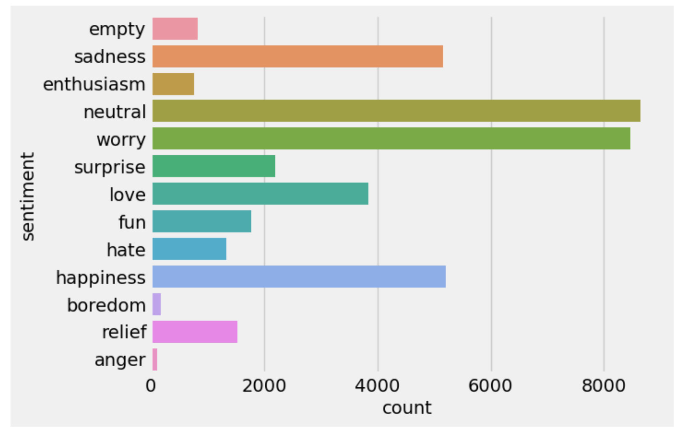

Figure 1: types of emotions included in the tweets

3- **Preparation of Quantum5**

In this part we will build the neural network layers which will be a combination of classical neural network and quantum layers.

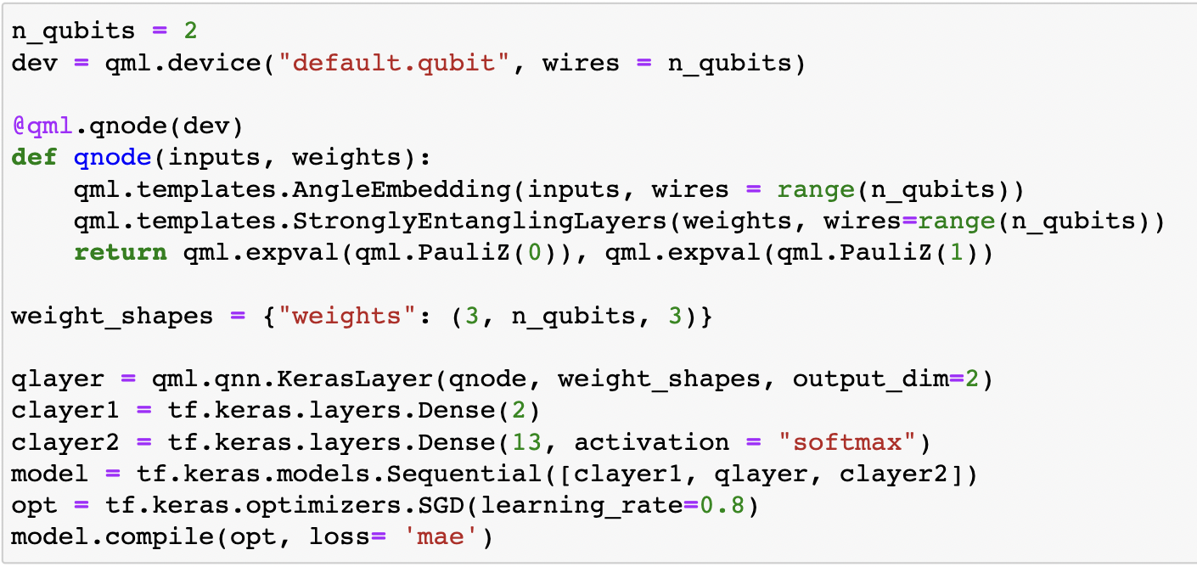

Figure 2: code snippet for building a combination of classical neural network layers and a quantum layer.

The code snippet uses a specific type of neural network called a quantum neural network (QNN) for quantum machine learning. In this case, the QNN is implemented using the Pennylane library, which is a popular library for quantum machine learning in Python.

The QNN is defined using the **qnode** function, which is decorated with **qml.qnode** to specify that it is a quantum node. The **AngleEmbedding** template is used to encode the input data into the quantum state of the qubits, and the **StronglyEntanglingLayers** template is used to perform parameterized quantum operations on the qubits.

The **qlayer** is created using **qml.qnn.KerasLayer**, which allows the QNN to be seamlessly integrated into a Keras model. The **qlayer** takes the **qnode** function as an argument, along with the desired weight shapes and output dimension.

The rest of the code defines a classical neural network model using the Keras API. It consists of two dense layers (**clayer1** and **clayer2**) and the **qlayer** in between them. The model is compiled with a stochastic gradient descent (SGD) optimizer and mean absolute error (MAE) loss.

Overall, the code combines classical neural network layers with a quantum layer to create a hybrid model that incorporates quantum computations into the machine learning process.

**4- Preparation of Prediction Data and Prediction Equation**

Now we will write a comment and the tokenize it and feed to the model In order to predict what emotions this comment carry.

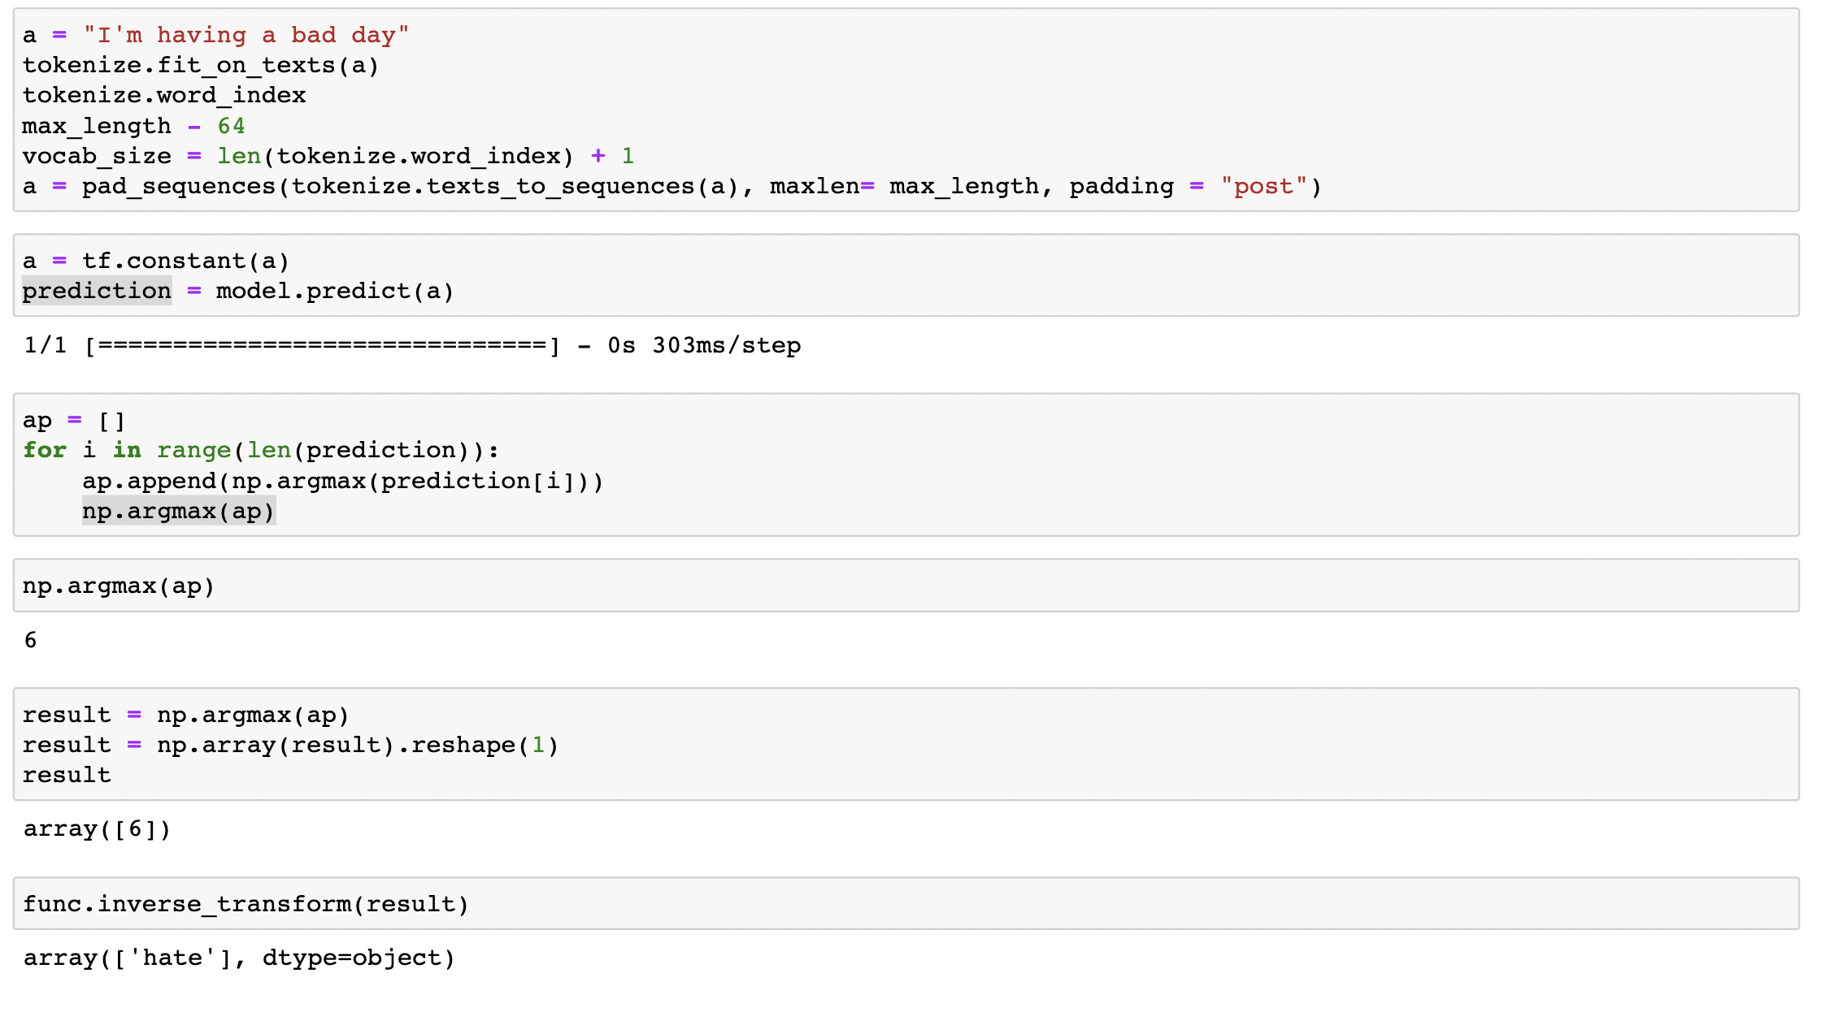

Figure 3: tokenizing a comment and then feeding it to the model to predict the emotions

As we can see the model was able to predict the emotions in the comment correctly.

**Conclusion**

In this project, a simulation using TensorFlow Quantum (TFQ) was developed to predict the emotions of tweets using a hybrid neural network. The goal was to leverage the capabilities of quantum computing within a classical machine learning framework to enhance the accuracy of emotion prediction.

The implemented code snippet showcases the construction of a hybrid model, combining classical neural network layers with a quantum layer. TFQ seamlessly integrates with TensorFlow, allowing for the integration of quantum operations within the neural network architecture.

The quantum layer, implemented using the Pennylane library, employs a quantum neural network (QNN) approach. By utilizing the qnode function, the input data is encoded into the quantum state of the qubits, enabling the application of parameterized quantum operations. The qlayer is then created using qml.qnn.KerasLayer, facilitating the incorporation of the QNN into the Keras model.

Additional processing and mapping capabilities are provided by the classical neural network layers (clayer1 and clayer2), which refine the predictions generated by the quantum layer. The model is compiled with a stochastic gradient descent optimizer and mean absolute error loss, enabling efficient training and evaluation.

Through the fusion of classical and quantum layers, this hybrid model can potentially capture intricate patterns and relationships within the tweet data, thereby improving the accuracy of emotion prediction. It is worth noting that the code snippet provided does not disclose details about the dataset used or the specific training and evaluation methodologies, which are vital for achieving reliable predictions.

In conclusion, TFQ offers a promising avenue for the development of hybrid models, leveraging quantum computing advantages within traditional machine learning frameworks. This opens up exciting possibilities for analyzing complex datasets, such as tweets, and predicting emotions with enhanced precision and insight.